Southwest Chicken Pinwheels

*serving size: 10*

Submitted by: Brittany C.



Directions

1. Shred rotisserie chicken.
2. Open can of RoTel and drain slightly.
3. Using a mixer, combine RoTel, cream cheese, sour cream, salt, and pepper until creamy.
4. Drain and rinse black beans.
5. Add green onions, black beans, cheese and shredded chicken.
6. Mix together with a spoon.
7. Spread a thin layer of mixture over tortilla, leaving a ½ inch border.
8. Roll tortilla up tightly.
9. Wrap the rollups individually with clear wrap.
10. Refrigerate for at least 1 hour and then slice into 2 inch pieces.

Ingredients

green onions

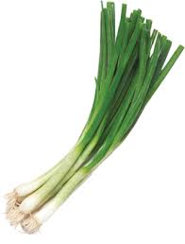

4 oz. black beans

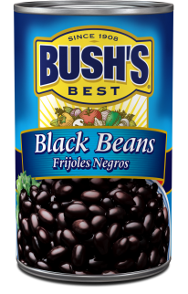

1 c. shredded cheddar cheese

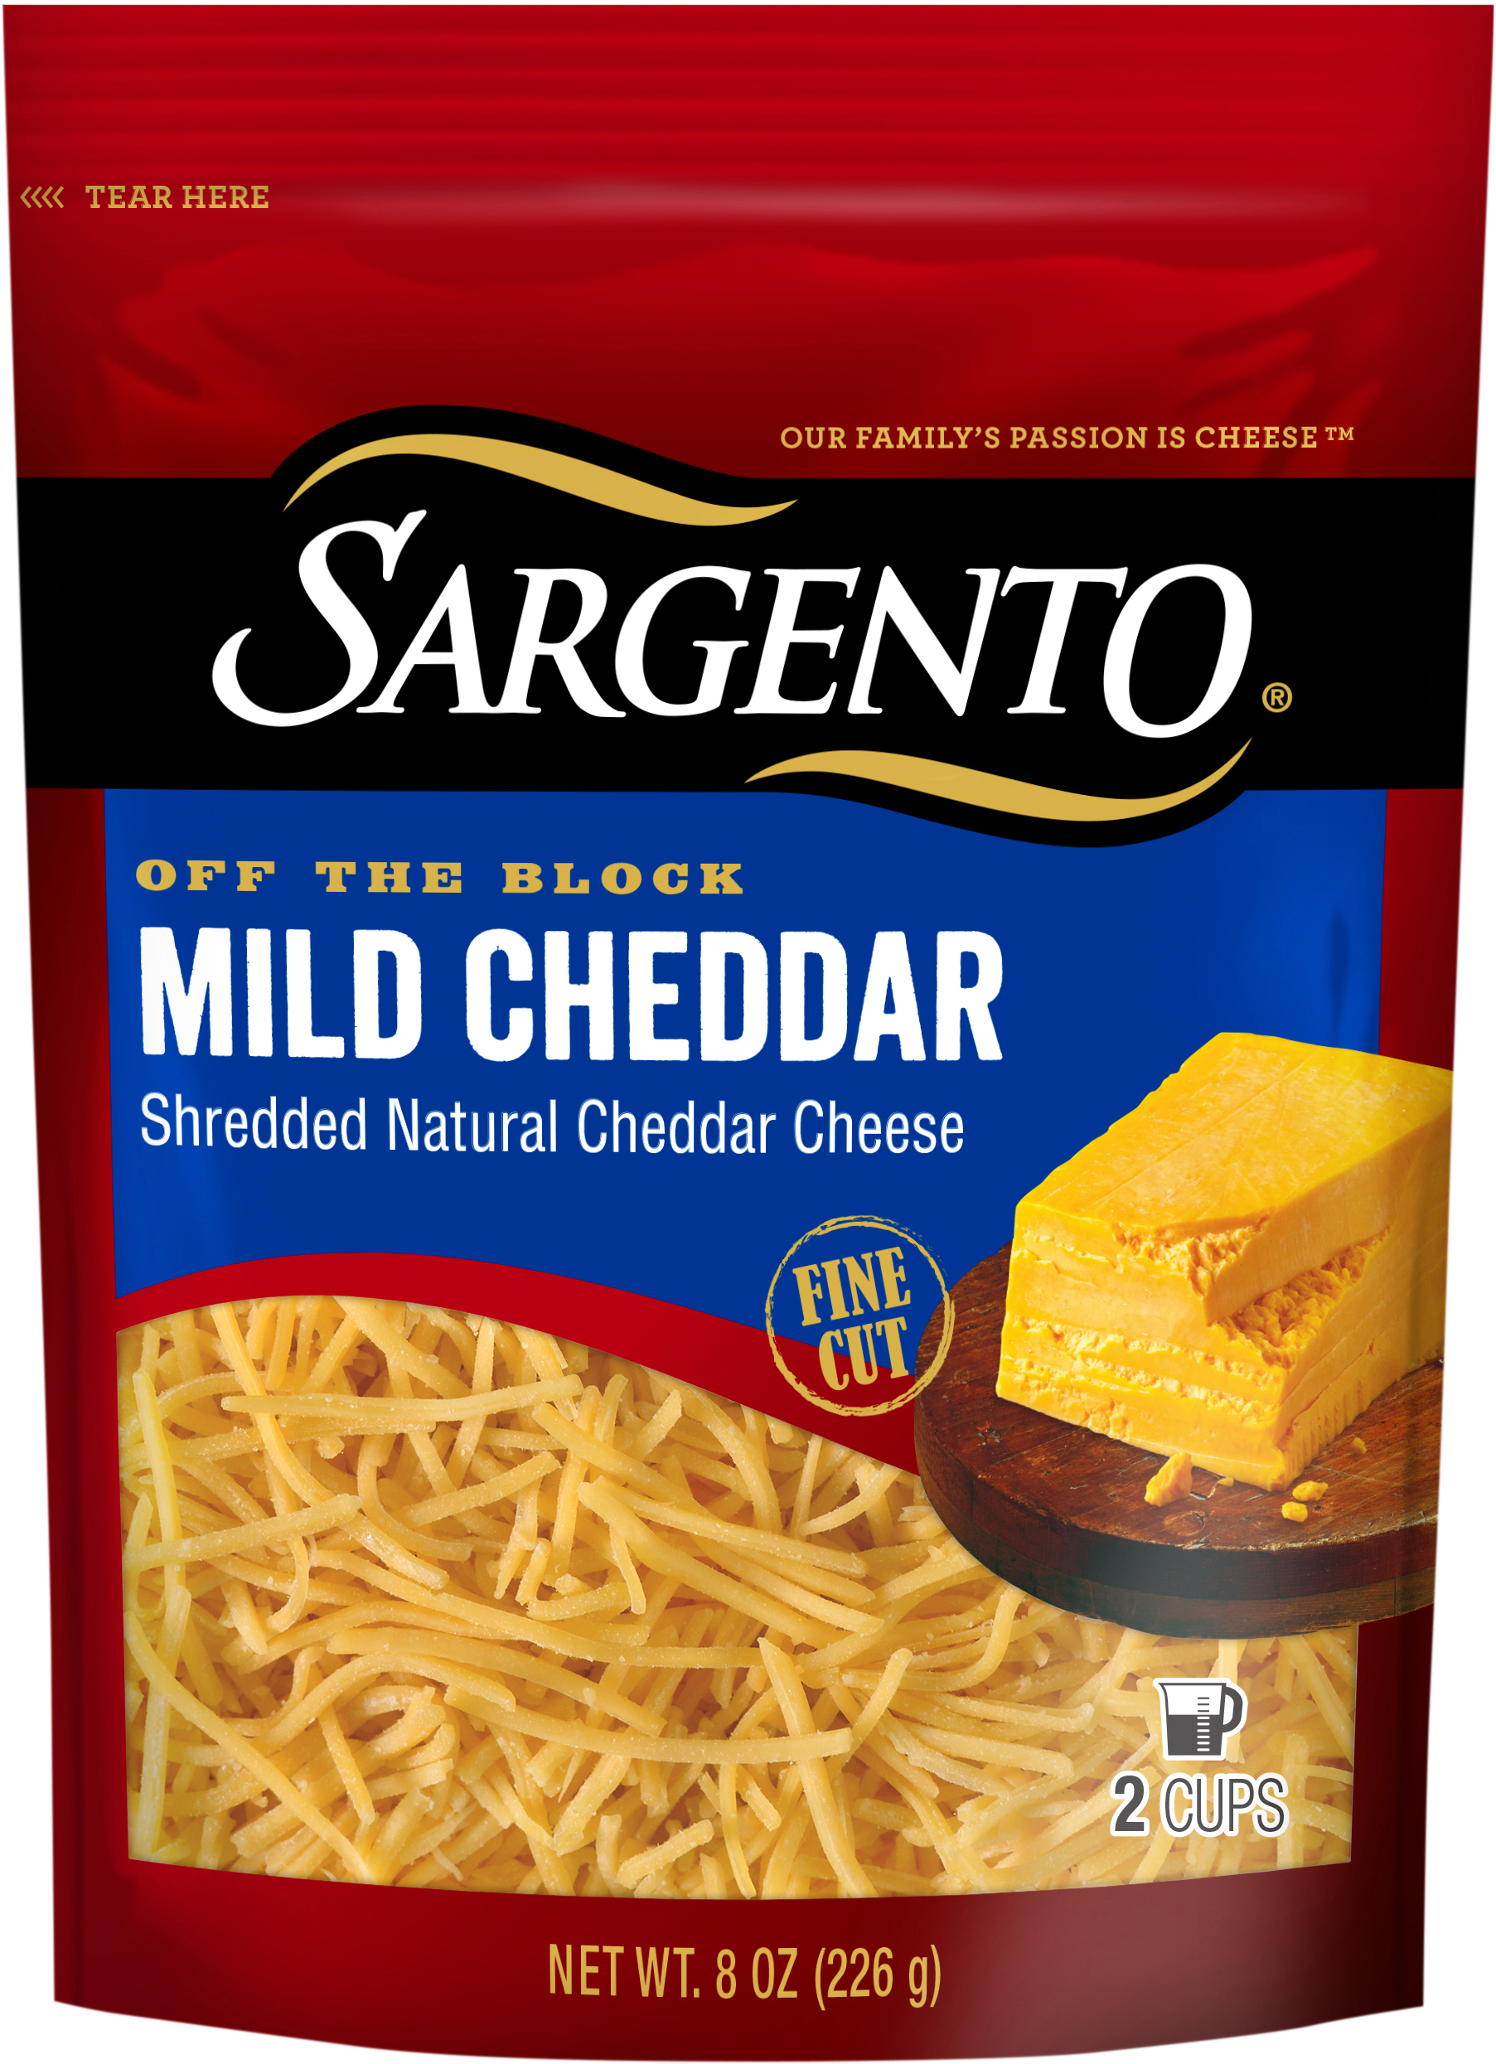

5 large tortillas

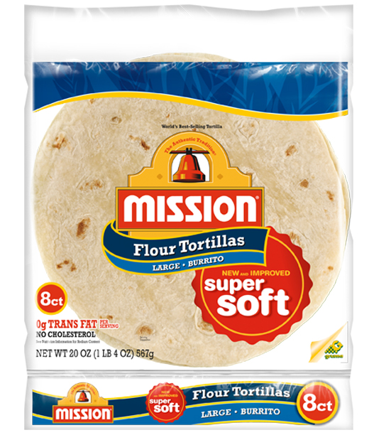

2 c. shredded rotisserie chicken

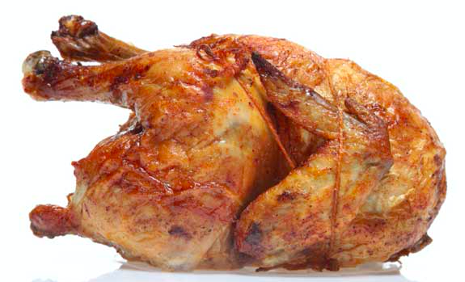

8 oz. cream cheese

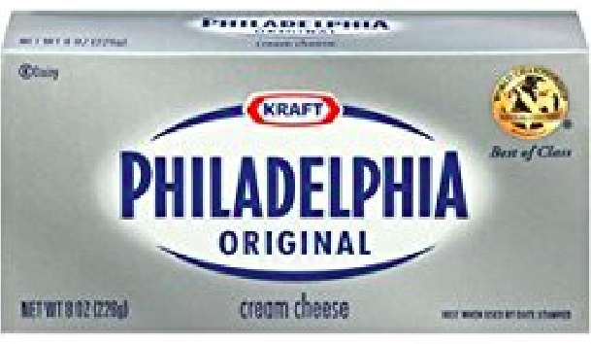

3 tbs. sour cream



1 can (10 oz.) RoTel tomatoes

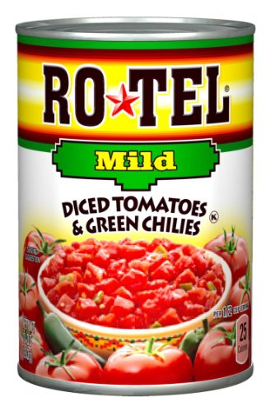

salt & pepper

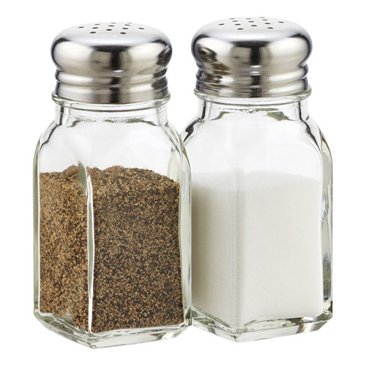

You will need:

 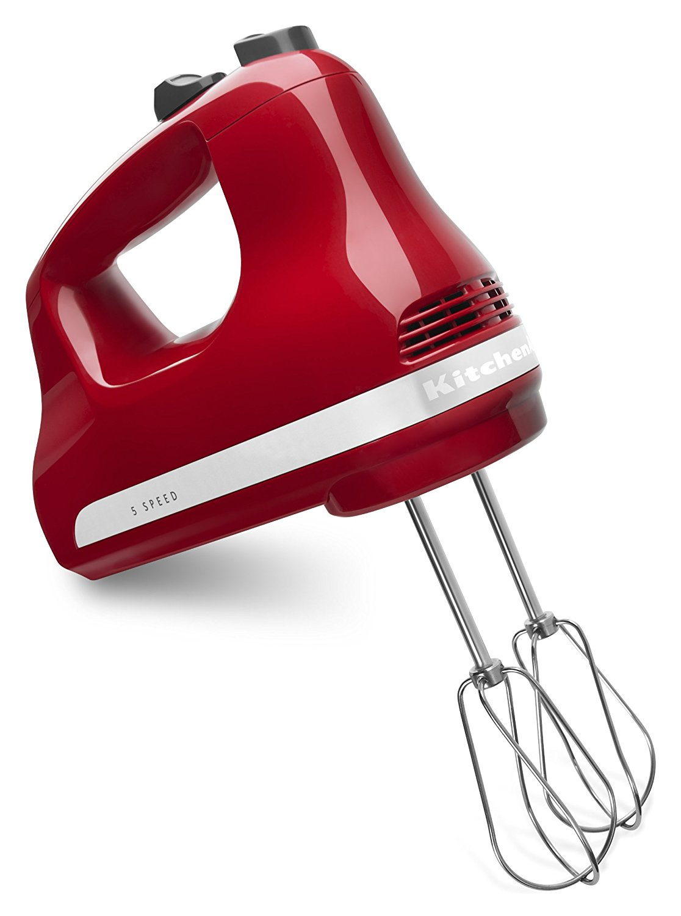 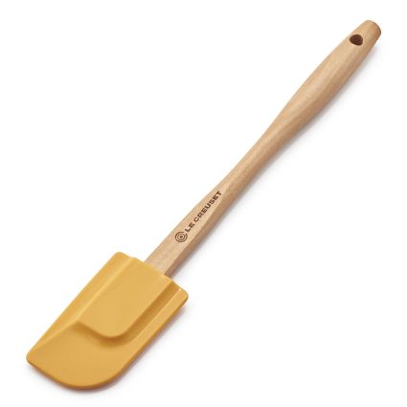 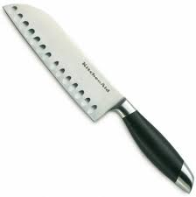 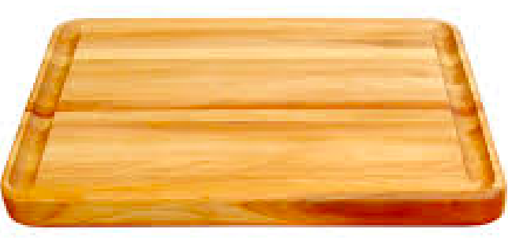  

mixing bowl mixer spatula knife cutting board measuring cups & spoons spoon

spoon